L E W - Love Equality Wisdom
Together we grow in wisdom inspired by the parable of the Good Samaritan - showing compassion to others; upholding dignity; supporting the potential in everyone.
Love
We demonstrate this through kindness, care, compassion and generosity. We ask children to treat others as they wish to be treated.
The Good Samaritan showed compassion and love to the stranger on the ground. God says we are called to help everyone regardless of difference and even when they are not our friends. We encourage this through our golden rule, through our collective worship and our curriculum teaching.
Equality
We demonstrate this through our aspiration for all regardless of disadvantage, background and need. This links directly to our historic foundations as a Church school.
Our education is for everyone and is equitable for all. We design our curriculum to teach children the values of respect, tolerance and courage – just like the Good Samaritan showed in his actions.
Wisdom
We educate our children to grow in wisdom – our curriculum is designed to give the children the knowledge and skills they need to be successful but also to develop the capabilities to be ready for their next stage in education and for the world of work and life.
The Good Samaritan helps us to see how wisdom is demonstrated through your actions, not just our intent. We must apply our learning in real life contexts with wisdom. We teach pupils to serve and contribute to their communities.

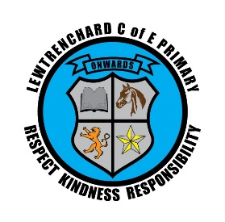
…. seeks to educate its children through the core Christian values demonstrated by the Good Samaritan: of kindness, responsibility and respect, encouraging pupils to live aspirational and fulfilled lives.
We do this by:
- being accountable for all of our actions; (Responsibility/Forgiveness)
- demonstrating integrity; (Respect/Honesty)
- being good stewards of our resources; (Care/Stewardship)
- serving others without self-interest. (Generosity/Compassion/Kindness)
Our vision is for everyone and shared with everyone:
children, families, staff and community.

