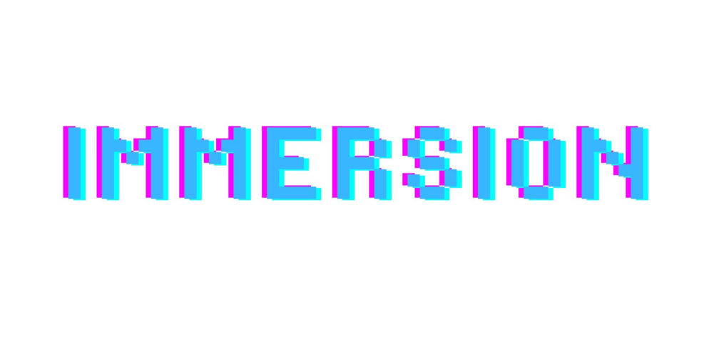

YEARS 2-6 VR and Lego Animation

LEW TRENCHARD PRIMARY SCHOOL 03/06/25 - 15/07/25

Immersion will be hosting a coding after school clubs at Lew Trenchard Primary School from Tuesday 3rd June till Tuesday 15th July. The club will run from 15.15 - 16.15 on the school site.

For this terms club children will have access to all the different clubs we’ve ran this school year! This includes our virtual reality headset with NEW games and experiences for them to try, Lego robots and animation, Kodu game design and Minecraft! Children will have complete freedom to do what they choose with a wide range of options and freeplay available, with no experience needed and all the equipment provided!

It is very important that you read the waiver that comes with this form. Without a signed form, children will not be able to take part in virtual reality sessions.

To register your child for this club please complete the below form and return it to Reception with the payment of £35 (£5 a session) or a cheque payable to

**RYAN ARTHURS**

To avoid disappointment please return the slip as soon as possible as we only have 20 places available for this session. Equipment will be provided for this session. ______________________________________________________________________

Lew Trenchard Primary School Coding club booking form

Child's Name:

Emergency contact number:

Medical conditions

Walk home/Pick up

I enclose payment of £35 (cheques payable to Ryan Arthurs or cash)

Signed(parent/guardian) ____________________________

Please read this document carefully. It is required to be signed before doing an Immersion Okehampton

VR experience, partaking in the use of the equipment or sessions

PLEASE NOTE: You will not be able to take part in Immersion Okehampton experiences without signing

this waiver.

HEADSET – To enter Virtual Reality you must wear a headset which will totally block your view of your real

location, and headphones that will prevent you from hearing the outside world. In the event of a fire

alarm, the system will shut down. If this happens, you should remove the headset and take

instructions from our team members.

WOW! – Our Virtual Reality experiences can be extremely realistic, creating unprecedented levels of

emotions. You can be scared, made to feel unsafe, unsure of your footings, or make you jump out of your

skin. Other titles can help you relax and unwind, wow you with wonder, or make you curious. We cannot

be held responsible for any injury caused by a players actions whilst reacting to VR. We do everything we

can to provide a safe environment.

A LIST OF POTENTIAL ISSUES THAT YOU MAY BE AFFECTED BY.

PLEASE READ AND CONSIDER HOW THEY MAY AFFECT YOUR CHILD BEFORE SIGNING THIS WAIVER AND

ENTERING VIRTUAL REALITY.

• Eye strain.

• High volumes in the headphones (There is a volume control).

• Flickering screens and flashing images which could trigger underlying health conditions.• Motion sickness.

• Equipment may affect some medical devices such as cardiac pacemakers etc.

• The equipment and media content of some experiences may affect those with pre-existing medical

or mental health conditions.

• May affect pregnant women adversely.

• It is possible to feel claustrophobia, panic, or other phobias.

• Objects in the real world may not be visible in the virtual world.

• Objects in the virtual world may not exist in the real world.

• Feelings of disorientation may be felt at the end of the experience.

HEALTH &amp; SAFETY – If at any time you have any health &amp; safety questions regarding you experiences at

Immersion, please ask a member of our team straight away. We recommend that you do not enter VR

when tired, or ill, in pain, or feel stressed or anxious in any way, as these factors can increase your risk of any

potential issues.

DISCOMFORT – Due to the unpredictable nature of the human response to virtual reality (dizziness,

nausea, seizures, fear of heights, bumping into objects, etc.), we require all participants to sign this waiver

releasing Immersion VR Limited from any liability regarding your (or your child/dependent/minor’s) use of

the VR equipment.

RISKS – Unfortunately, there are risks associated with the use of VR (Virtual Reality) headsets. Some of the

risks are fairly obvious: bumping into objects, tripping over wires, etc. Other risks are not so obvious and

may either be latent in their effects (for example, vision impairment) or may trigger dizziness, nausea or

even a seizure. The fact is, the technology is so new that health and safety research needs to catch up with

it.

I agree to follow directions of Immersion its officers, servants, agents, instructors and third party

organisers and understand that if I am deemed to be behaving recklessly or dangerously I may be excluded

from the Event.

I acknowledge that I am solely responsible for any decision as to my childs fitness and ability to participate in

the Event. I am aware that damage I cause to equipment provided by Immersion is my responsibility and I will

meet any costs for any such damage and/or wear and tear.

WAIVER – Because of the risks associated with the use of VR, Immersion VR requires that a waiver

is signed prior to using the Immersion VR equipment.

Please stop use of the VR equipment if you feel any discomfort whatsoever.

BY USING ONE OF THE IMMERSION OKEHAMPTON VIRTUAL REALITY HEADSETS AND/OR

THE EQUIPMENT WITHIN THE ARCADE YOU ARE INDICATING YOUR ACCEPTANCE OF THE

TERMS AND CONDITIONS OF THIS AGREEMENT.

I (or my child/dependent/minor) wish to use one of Immersion Okehampton Virtual Reality

headsets. I recognise and understand that the use of a VR headset involves certain risks. I

understand that I must sign this Release of Liability in person before using the equipment

provided by Immersion Okehampton