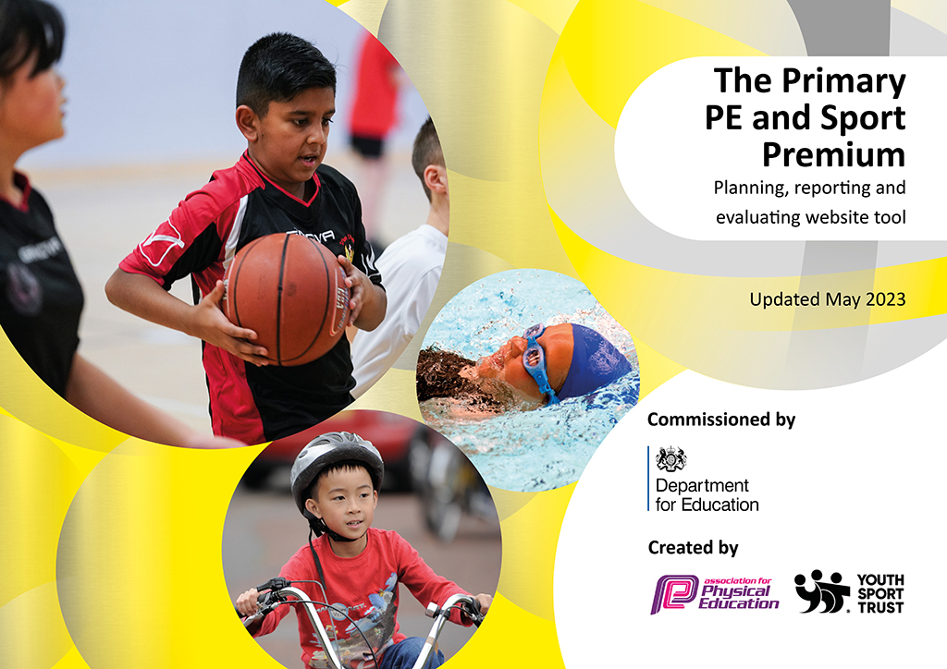
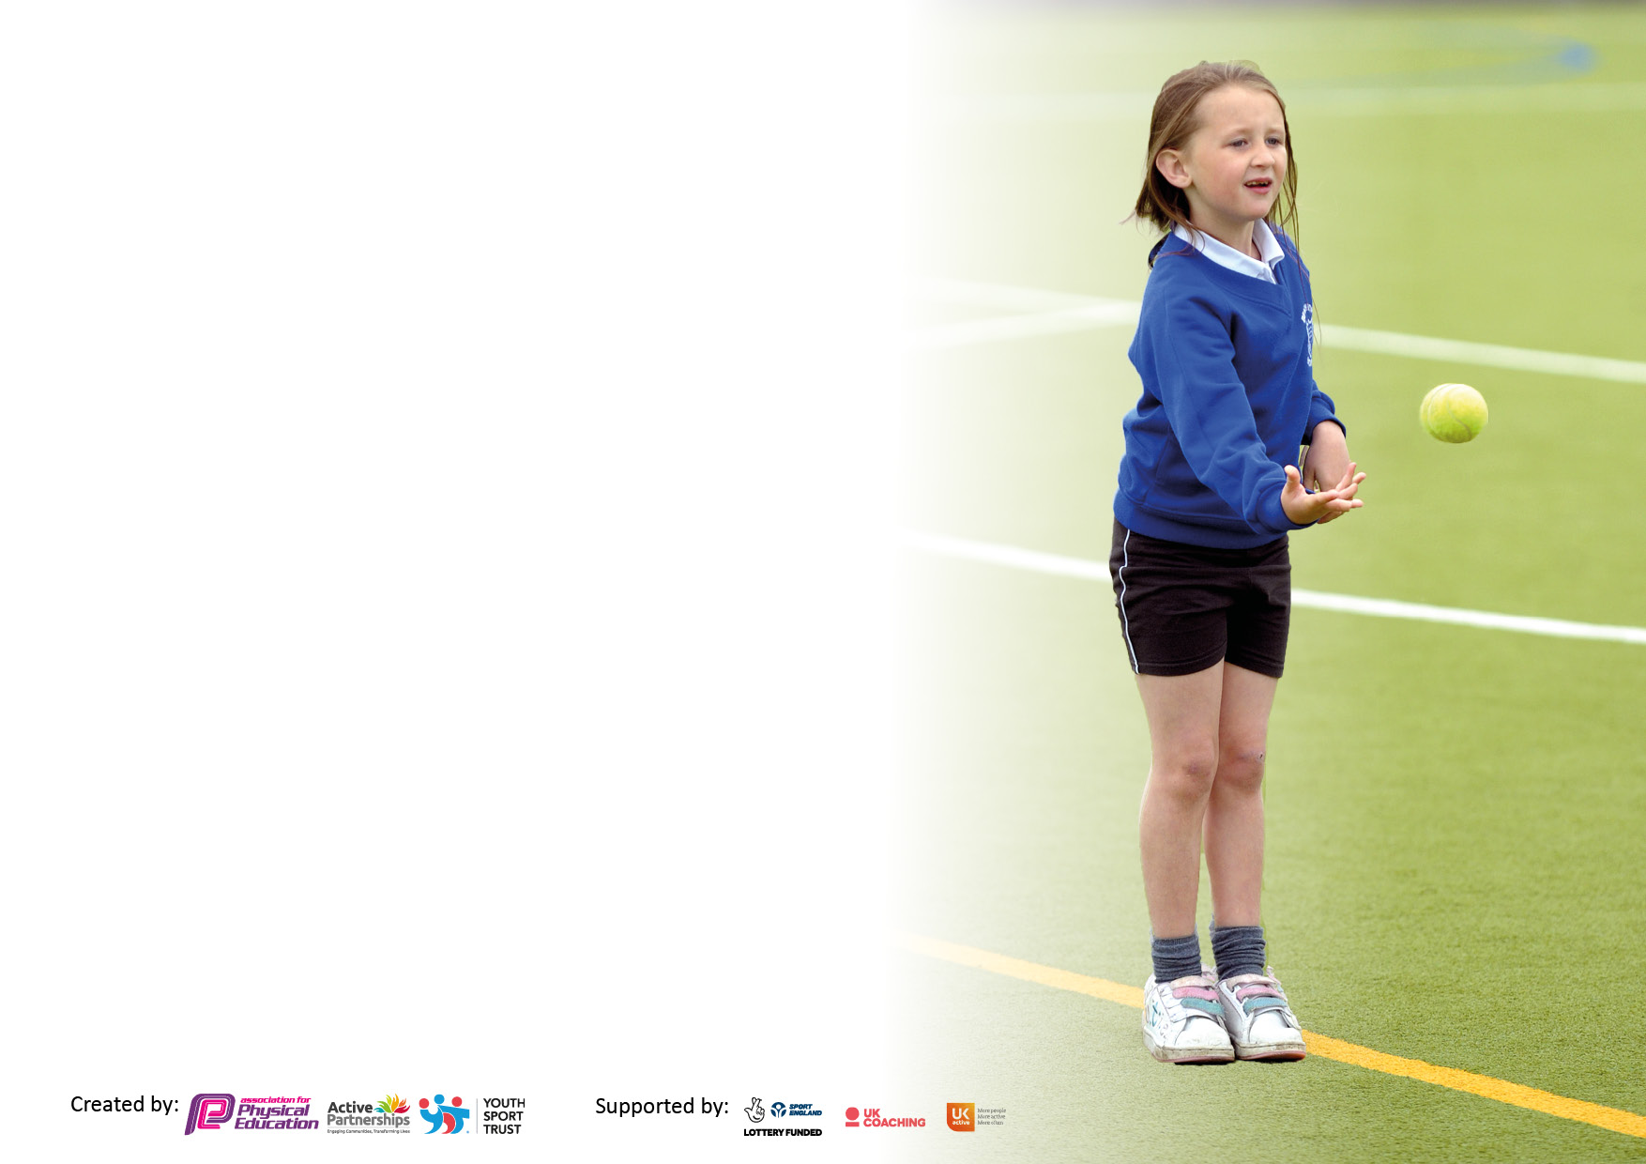

It is important that your grant is used effectively and based on school need. The Education Inspection Framework makes clear there will be a focus on ‘whether leaders and those responsible for governors all understand their respective roles and perform these in a way that enhances the effectiveness of the school’.

Under the Quality of Education Ofsted inspectors consider:
Intent - Curriculum design, coverage and appropriateness
Implementation - Curriculum delivery, Teaching (pedagogy) and Assessment
Impact - Attainment and progress

To assist schools with common transferable language this template has been developed to utilise the same three headings which should make your plans easily transferable between working documents.

Schools must use the funding to make additional and sustainable improvements to the quality of Physical Education, School Sport and Physical Activity (PESSPA) they offer. This means that you should use the Primary PE and sport premium to:

- Develop or add to the PESSPA activities that your school already offer
- Build capacity and capability within the school to ensure that improvements made now will benefit pupils joining the school in future years
- The Primary PE and sport premium should not be used to fund capital spend projects; the school’s budget should fund these.

Please visit gov.uk for the revised DfE guidance including the5keyindicatorsacrosswhichschoolsshoulddemonstrate an improvement. This document will helpyoutoreviewyourprovisionandtoreportyourspend.DfEencouragesschools to use this template as an effective way of meeting the reporting requirements of the Primary PE and Sport Premium.

We recommend you start by reflecting on the impact of current provision and reviewing the previous spend.

Schools are required to publish details of how they spend this funding, including any under-spend from 2021/2022, as well as on the impact it has on pupils’ PE and sport participation and attainment. The funding should be spent by 31st July but the DfE has stated that there will be no clawback of any unspent money so this can be carried forward into 2023/24.

We recommend regularly updating the table and publishing it on your website throughout the year. This evidences your ongoing self-evaluation of how you are using the funding to secure maximum, sustainable impact. Final copy must be posted on your website by the end of the academic year and no later than the 31st July 2023. To see an example of how to complete the table please click HERE.

Details with regard to funding
Please complete the table below.

Total amount carried over from 2021/22 | £0
Total amount allocated for 2021/22 | £0
How much (if any) do you intend to carry over from this total fund into 2022/23? | £0
Total amount allocated for 2022/23 | £16720
Total amount of funding for 2022/23. Ideally should be spent and reported on by 31st July 2023. | £ 0
Swimming Data
Please report on your Swimming Data below.

Meeting national curriculum requirements for swimming and water safety.

N.B. Complete this section to your best ability. For example you might have practised safe self-rescue techniques on dry land which you can then transfer to the pool when school swimming restarts.
Due to exceptional circumstances priority should be given to ensuring that pupils can perform safe self rescue even if they do not fully meet the first two requirements of the NC programme of study
What percentage of your current Year 6 cohort swim competently, confidently and proficiently over a distance of at least 25 metres?  N.B. Even though your pupils may swim in another year please report on their attainment on leaving primary school at the end of the summer term 2023.  Please see note above | 79%
What percentage of your current Year 6 cohort use a range of strokes effectively [for example, front crawl, backstroke and breaststroke]?  Please see note above | 79%
What percentage of your current Year 6 cohort perform safe self-rescue in different water-based situations? | 86%
Schools can choose to use the Primary PE and sport premium to provide additional provision for swimming but this must be for activity over and above the national curriculum requirements. Have you used it in this way? | Yes/No

Action Plan and Budget Tracking
Capture your intended annual spend against the 5 key indicators. Clarify the success criteria and evidence of impact that you intend to measure to evaluate for pupils today and for the future.

Academic Year: 2022/23 | Total fund allocated: | Date Updated:
Key indicator 1: The engagement of all pupils in regular physical activity – Chief Medical Officers guidelines recommend that primary school pupils undertake at least 30 minutes of physical activity a day in school |  |  |  | Percentage of total allocation:
 |  |  |  | %8
Intent | Implementation |  | Impact
Your school focus should be clear what you want the pupils to know and be able to do and about  what they need to learn and to  consolidate through practice: | Make sure your actions to achieve are linked to your intentions: | Funding allocated: | Evidence of impact: what do pupils now know and what can they now do? What has changed?: | Sustainability and suggested next steps:
PE subject leader to develop offer of clubs, making links with the community. | A wider range of clubs to be offered. | Costed as part of package below. | A wider range of clubs has been introduced and links to the community opened. Wider engagement in uptake from children evident. | To carry open making further links to the community.
Programme to monitor participation data. | Absolute Education purchased | £300 | Participation is tracked and clubs changed to raise participation. | KS1 uptake to increase.
Raise participation in after-school clubs. | Outside coach to provide 24 x 1 hour sessions. | £972 | All children from Reception – Year 6 given opportunity to participate in a club. | Make community links to help run these sessions,
Purchase of equipment to support with curriculum delivery and break/lunch times. | Soft balls and playground equipment purchased. | £92 | Children use the equipment at break times, whilst supporting the delivery of PE.
Key indicator 2: The profile of PESSPA being raised across the school as a tool for whole school improvement |  |  |  | Percentage of total allocation:
 |  |  |  | %30
Intent | Implementation |  | Impact
Your school focus should be clear what you want the pupils to know and be able to do and about  what they need to learn and to  consolidate through practice: | Make sure your actions to achieve are linked to your intentions: | Funding allocated: | Evidence of impact: what do pupils now know and what can they now do? What has changed?: | Sustainability and suggested next steps:
PE subject leader time to develop and deliver PE across the school. | To ensure that there is a broad and balanced curriculum in place throughout the school, curriculum maps are in place, assessment is implemented, and policies are all updated. | £4535 | Children get access to a comprehensive, high quality PE programme across the school which raises their confidence, achievement and attainment in PE and wider curriculum. | Due to sustainable plan, PE delivery continues to develop for the future.
Deep Dive into PE | To ensure that all areas of PESSPA are of a high standard. | £315 | Report indicates that the subject is delivered to a high standard and all children have access to high quality PESSPA. | Due to sustainable plan, PE delivery continues to develop for the future.
Wild tribe award to be provided. | Wile Tribe award purchased from ARENA. | £135 | To be introduced September 23.

Key indicator 3: Increased confidence, knowledge and skills of all staff in teaching PE and sport |  |  |  | Percentage of total allocation:
 |  |  |  | %30
Intent | Implementation |  | Impact
Your school focus should be clear | Make sure your actions to | Funding | Evidence of impact: what do | Sustainability and suggested
what you want the pupils to know | achieve are linked to your | allocated: | pupils now know and what | next steps:
and be able to do and about | intentions: |  | can they now do? What has
what they need to learn and to |  |  | changed?:
consolidate through practice:
Qualified teacher from outside agency to come in twice a week for 12 weeks to provide CPD opportunities for staff in dance and gymnastics. | Upskill teaching staff in dance and gymnastics. | £2376 | Through staff audit, teachers now feel more confident and competent to teach these areas of the curriculum. | Teachers will deliver dance and gymnastics next year.
Members of ARENA sports partnership. | Access to a range of CPD opportunities, PE conferences and webinars. | £450 | Teachers and support staff have been given opportunities to attend conferences and webinar and been directed for CPD opportunities. | Teachers and support staff confident and competent to deliver our curriculum and interventions.
1 day swimming course | Increase teacher’s confidence to deliver swimming curriculum. | £150 | Teacher feels more confident delivering swimming, which has been used during swimming lessons this year. | Provide similar training for all relevant staff.
Gymnastics equipment to be purchased | Equipment to be used to support the curriculum delivery. | £1260 | Equipment have allowed the staff to carry out a wider range of PE provision and give children access to a range of sports. | Sustainability: Equipment will be used for the foreseeable future to deliver high quality PE.
Replenishing equipment of PE curriculum. | Netballs and basketballs purchased and used. | £381 | Equipment have allowed the staff to carry out a wider range of PE provision and give children access to a range of sports. | Sustainability: Equipment will be used for the foreseeable future to deliver high quality PE.
Subscription for scheme of learning renewed to make teaching and assessing more consistent across the school. | Scheme to be used across the school. | £421 | Teachers are more confident in the delivery of these curriculum areas. Children more confident and attaining higher level within these areas.
Key indicator 4: Broader experience of a range of sports and activities offered to all pupils |  |  |  | Percentage of total allocation:
 |  |  |  | 14%
Intent | Implementation |  | Impact
Your school focus should be clear | Make sure your actions to | Funding | Evidence of impact: what do | Sustainability and suggested
what you want the pupils to know | achieve are linked to your | allocated: | pupils now know and what | next steps:
and be able to do and about | intentions: |  | can they now do? What has
what they need to learn and to |  |  | changed?:
consolidate through practice:
Additional achievements:  Alternative Sports Day to be delivered | Alternative Sports day implemented within school. | £800 | Children have been provided the opportunity to try a wider range of different sports. This will allow them different opportunities and enthuse children to try these sports. | Look at investing in equipment for some of these sports and add it to our curriculum/after-school club provision.
After trialing and the success of this last year, archery equipment to be purchased. | An archery club to be provided. | £685 | 34% of children took part within the club. | To look at local clubs/competitions.
To make community links and offer a wider range of opportunities. | Climbing club offered at a local venue. | £300 | 12 children from KS2, including 3 children with EHCPs, accessed a 6-week course. | Open this up to a wider group.
Participate in a MAT dance celebration. | Dance coach to provide sessions to create dance, to be showcased at the MAT celebration. | £300 | 3 sessions provided to Year 5/6 cohort, who performed this at Launceston Castle. | With other MAT schools, make this a yearly tradition.
Children to spend a day on the local moors. | ARENA to lead a moorland day for KS1 & KS2 | £337.50 | All children form KS1 & KS2 spent a day, exploring the moors and orienteering their way around. | Provide CPD for member of staff to run this ourselves going forward.  Moorland leader award to be used to begin Ten Tors challenge with Year 6.

Key indicator 5: Increased participation in competitive sport |  |  |  | Percentage of total allocation:
 |  |  |  | %10
Intent | Implementation |  | Impact
Your school focus should be clear | Make sure your actions to | Funding | Evidence of impact: what do | Sustainability and suggested
what you want the pupils to know | achieve are linked to your | allocated: | pupils now know and what | next steps:
and be able to do and about | intentions: |  | can they now do? What has
what they need to learn and to |  |  | changed?:
consolidate through practice:
Membership to OCRA for competitions and events | To provide children with a range of competitive events for all children to lead to the Devon games. | £1600 | 85% of children have participated in in-school competitions with 30% pupils involved in competition outside of school. | To provide more opportunity for KS1 children to participate in out-of-school competition and a wider range of sporting competitions.
ANDARAS MAT competitions include with ARENA membership. | To provide children with a range of competitive events against other MAT schools. | Costed as part of ARENA membership.
Raise Sports Day competition. | Invest in house trophy generate more competition. | £25 | All children were more competitive and willing to participate in more events. | This will leave a legacy and give children more incentive to participate, increasing participation.

Signed off by
Head Teacher: | L.Davy
Date: | 25.07.2023
Subject Leader: | D.Payton
Date: | 25/07/2023
Governor: | A.Crompton
Date: | 30.07.23

