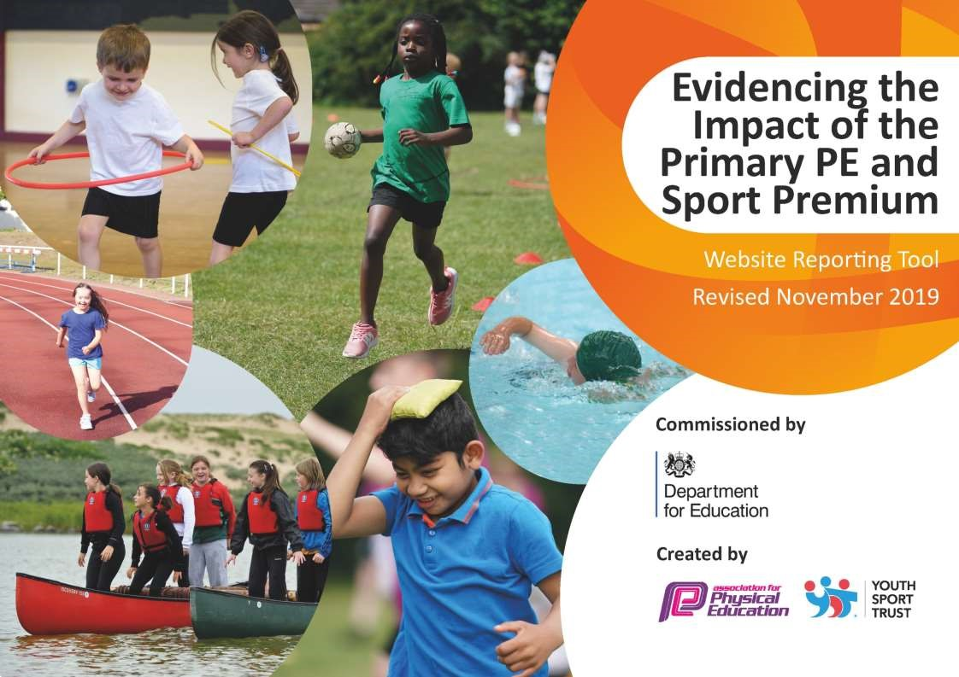

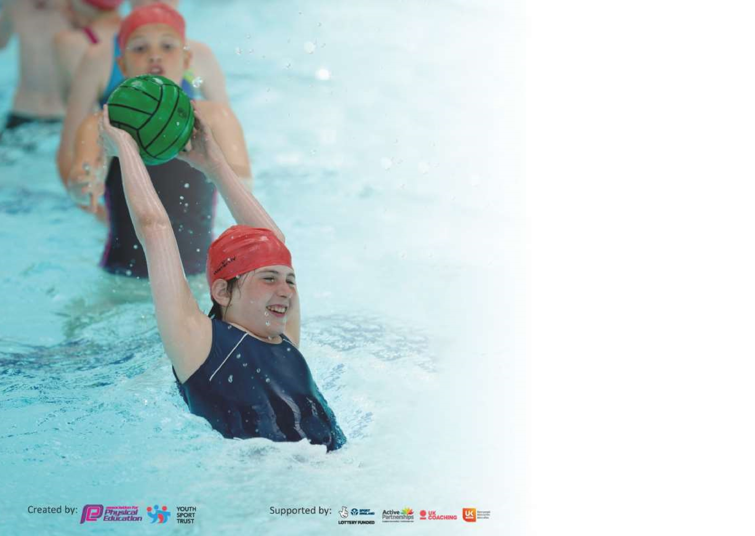

It is important that your grant is used effectively and based on school need. The
Education Inspection Framewor
k

(
Ofsted 2019 p64) makes clear there will be a focus on
‘whethe
r leaders and those responsible for governors all
understand their respective roles and perform these in a way that enhances the effectiveness of the school’
.

Under

the

Qualit
y

o
f

Educatio
n

criteri
a

(
p41)

inspectors

consider

the

extent

to

which

schools

can

articulate
their curriculum (INTENT), construct their curriculum
(
IMPLEMENTATION)
and
demonstrate the outcomes
which result

(
IMPACT
).

To assist schools with common transferable language this template has been developed to utilise the same
three headings which should make your plans easily transferable between working documents.

Schools mu
st use the funding to make
additional and sustainable
improvements to the quality of
Physical Education, School Sport and Physical Activity

(
PESSPA)
they
offer.
This means that you should

use the Primary PE and Sport Premium to:

•

Develop or add to the
PESSPA
activities that your school already

offer

•

Build capacity and capability within the school to ensure that improvements made now

will
benefit pupils joining the school in future

years

Please visit
gov.u
k

f
or the revised DfE guidance including the 5 key indicators across which
schools should demonstrate an improvement. This document will help you to review your
prov
ision and to report your spend. DfE encourages schools to use this template as an
effective way of meeting the reporting requirements of the Primary PE and Sport Premium.

We recommend you start by reflecting on the impact of current provision and reviewin
g the
previous spend.

Schools are required to
publish detail
s

o
f how they spend this funding as well as on the
impact
it has on pupils’ PE and sport participation and attainment by the end of the
summer term or by
31
st
July 2020
at the latest.

We recommend regularly updating the table and publishing it on your website
throughout the year. This evidences your ongoing self
-
evaluation of how you are
using the funding to secure maximum, sustainable impact. Final copy must be
posted on your website b
y the end of the academic year and no later than the
31
st July 2020. To see an example of how to complete the table please click
HER
E
.

Support for review and reflection - considering the 5 key indicators from DfE, what development needs are a priority for your setting and your pupils now and why? Use the space below to reflect on previous spend and key achievements and areas for development.

Key achievements to date until July 2019: | Areas for further improvement and baseline evidence of need:
- Some staff CPD undertaken to improve knowledge in delivering Physical Education.  - High uptake of physical related extra-curricular activities.  - Began to compete in a range of various competitions, both within the trust and wider community.  - Supported all children with their mental well-being through taught yoga sessions. | - To ensure there is clear progression in the delivery of curriculum PE.  - Ensure that the assessment of Physical Education is regular and consistent.  - Provide a wider range of activities within Physical Education lessons to ensure that all objectives are adhered to and provide all children with an opportunity to develop their physical literacy.  - Invest in a wider range of equipment to support in the teaching of Physical Education.

Meeting national curriculum requirements for swimming and water safety.
What percentage of your current Year 6 cohort swim competently, confidently and proficiently over a distance of at least 25 metres?  N.B. Even though your pupils may swim in another year please report on their attainment on leaving primary school at the end of the summer term 2020. | Figures based on the children’s previous data from lessons throughout their year 5 swimming lesson. Due to Covid-19 the year 6 summer swimming did not happen.
What percentage of your current Year 6 cohort use a range of strokes effectively [for example, front crawl, backstroke and breaststroke]? | Figures based on the children’s previous data from lessons throughout their year 5 swimming lesson. Due to Covid-19 the year 6 summer swimming did not
Created by: Supported by:

 | happen.
What percentage of your current Year 6 cohort perform safe self-rescue in different water-based situations? | Due to Covid-19 our top up swimming and water rescue lessons were not able to run as planned.
Schools can choose to use the Primary PE and Sport Premium to provide additional provision for swimming but this must be for activity over and above the national curriculum requirements. Have you used it in this way? | Yes | /No

Action Plan and Budget Tracking
Capture your intended annual spend against the 5 key indicators. Clarify the success criteria and evidence of impact that you intend to measure to evaluate for pupils today and for the future.

Academic Year: 2020/21 | Total fund allocated: £16,800 (£6638.50 Covid underspend) | Date Updated: July 2021 |  | Total fund used: £ 23,438.50
Key indicator 1: The engagement of all pupils in regular physical activity – Chief Medical Officer guidelines recommend that primary school pupils undertake at least 30 minutes of physical activity a day in school |  |  |  | Percentage of total allocation:
 |  |  |  | >1%
Intent | Implementation |  | Impact
Your school focus should be clear what you want the pupils to know and be able to do and about what they need to learn and to consolidate through practice: | Make sure your actions to achieve are linked to your intentions: | Funding allocated: | Evidence of impact: what do pupils now know and what can they now do? What has changed? | Sustainability and suggested next steps:
Increase daily activity and exercise during school hours. | BBC Super Movers used throughout the school to support learning of other curriculum subjects.  Invest in a range equipment for all children to use at break and lunch time. | Free  £80 | Classes can use Super Movers when necessary but are often encouraged to use this to ensure physical activity is regularly being undertaken.  All children have access to equipment during break and lunch times.  95% of pupils active during break and lunch time. | Sustainability:  During COVID closure, the equipment has become paramount to encouraging children to remain outdoors.  Next Step:  Look at investing in a wider range of equipment to support children across all year groups.

 | Started to implement the Daily Mile initiative across the school. This will promote moving roughly a mile per day. | Free | All classes have begun to implement the initiative in their own timeframe. Children have enjoyed the initiative and becoming more active.  25% of children participate in the scheme. | Sustainability:  Non-negotiable in class time tables.  Next step:  Ensure that this the scheme is implemented daily across all classes.
Key indicator 2: The profile of PESSPA being raised across the school as a tool for whole school improvement |  |  |  | Percentage of total allocation:
 |  |  |  | 0%
Intent | Implementation |  | Impact
Your school focus should be clear what you want the pupils to know and be able to do and about what they need to learn and to consolidate through practice: | Make sure your actions to achieve are linked to your intentions: | Funding allocated: | Evidence of impact: what do pupils now know and what can they now do? What has changed? | Sustainability and suggested next steps:
To deliver outdoor first aid training to upper KS2 children. | Introduce First programme to a mixed UKS2 class. The course allows pupils to develop their confidence in first aid within the outdoors. | Free  Funding allocated in 19/20. | Pupils developed independence and confidence in outdoor learning. Children developed lifelong learning skills in first aid.  18 children achieved wild tribe first aid certificate. | Sustainability:  Staff upskilled in delivery of first aid.  Next steps:  Knowledge to be shared across school.

Key indicator 3: Increased confidence, knowledge and skills of all staff in teaching PE and sport |  |  |  | Percentage of total allocation:
 |  |  |  | 64%
Intent | Implementation |  | Impact
Your school focus should be clear | Make sure your actions to | Funding | Evidence of impact: what do | Sustainability and suggested
what you want the pupils to know | achieve are linked to your | allocated: | pupils now know and what | next steps:
and be able to do and about | intentions: |  | can they now do? What has
what they need to learn and to consolidate through practice: |  |  | changed?
Subject leader award training to be provided for curriculum lead.  Qualified teacher from outside agency to come in twice a week for 18 weeks to provide CPD opportunities for staff.  Members of ARENA sports partnership.  Qualified coaches from outside agency to provide PE session once a week and upskill staff within specific areas of curriculum.  PE subject leader time to develop and deliver PE across the school.  Qualified teacher from outside agency to come in three times a week for 6 weeks to cover Key Worker Groups  Qualified teacher from outside agency to come in twice a week for 14 weeks to provide CPD opportunities for staff and after school curriculum. | Attendance at a four-day course to upskill PE leader.  Upskill staff in gymnastics, rugby, netball and dance.  Access to a range of CPD opportunities, PE conferences and webinars.  Upskill staff’s skills and knowledge of football, basketball and ball skills.  To ensure that there is a broad and balanced curriculum in place throughout the school, curriculum maps are in place, assessment is implemented and policies are all updated.  To provide Key Worker children opportunity to participate in physical activity.  Upskill staff’s skills and knowledge of tennis, cricket and orienteering. | £382.50  £3269.71  £450  £1170  £3250  £1755.94  £3425 | As a result of attending the course, subject leader will be qualified to lead PE and transfer knowledge and skills across the school.  Teachers and TAs reported that they are more confident in the delivery of these curriculum areas. Children more confident and attaining higher level within these areas.  80 children have had access to specialist teaching in these areas.  Teachers have been given opportunities to attend conferences and webinar and been directed for CPD opportunities.  Children have been upskilled in the learning and knowledge of invasion games and tactics.  Children get access to a comprehensive, high quality PE programme across the school which raises their confidence, achievement and attainment in PE.  All Key worker children were more physically active during Lockdown.  Teachers and TAs reported that they are more confident in the delivery of these curriculum areas. Children more confident and attaining higher level within these areas.  80 children have had access to specialist teaching in these areas. | Sustainability:  Training can be transferred and subject leader will have the knowledge to lead subject in the future.  Next Step: To continue to provide further training opportunities for the subject leader.  Sustainability: Staff can cascade knowledge to other staff members and deliver content in the future.  Teachers and TAs have become more confident in the delivery of these areas.  Due to sustainable plan, PE delivery continues to develop for the future.  Importance of physical activity should ensure that children continuously remain physically active.  Sustainability: Staff can cascade knowledge to other staff members and deliver content in the future.

Purchase a scheme of learning or assessment system to make  Teaching and assessing more consistent across the school.  Purchase a set of iPads to enable the staff to use the app fully. | New assessment scheme implemented within the school.  With video support for accurate teaching points, self and peer assessing, leading to opportunities for leadership/coaching. | £1350 (Covid underspend)  £1999 (Covid underspend) | Lesson and unit content are easy to follow and staff have reported it is time saving and useful to be able to assess in the moment on the iPad.  Teachers confident in using iPads to assess children in PE. | where children can access  their own areas to increase ICT use in PE.  Next Step:  To ensure that assessment becomes embedded across the school.
Key indicator 4: Broader experience of a range of sports and activities offered to all pupils |  |  |  | Percentage of total allocation:
 |  |  |  | 12%
Intent | Implementation |  | Impact
Your school focus should be clear | Make sure your actions to | Funding | Evidence of impact: what do | Sustainability and suggested
what you want the pupils to know | achieve are linked to your | allocated: | pupils now know and what | next steps:
and be able to do and about | intentions: |  | can they now do? What has
what they need to learn and to consolidate through practice: |  |  | changed?:
Health and wellbeing day provided by ARENA for all pupils in the school.  Athletics club provided for six weeks.  Five different after school clubs provided so far, this academic year. To be updated later on in the academic year.  Purchase five National Curriculum outdoor books.  Purchase new PE equipment and shed. | Health and wellbeing day implemented.  Club implemented.  New clubs implemented with different coaches and specialists.  Books purchased.  Equipment to be used for the provision of PE across the school. | Free  Spending from 19/20.  £207  Costed above  £270.  £105 (Covid underspend)  £2483.57  (Covid underspend) | Children have been provided the opportunity to experience a range of different workshops, including sugar smart, healthy hearts and healthy minds etc. This would extend their knowledge in health and wellbeing. Staff upskilled in delivery a range of health and wellbeing workshops.  66% of pupils have taken part in after school provision.  Teachers using the books to assist with the delivery of outdoor learning sessions.  Equipment have allowed the staff to carry out a wider range of PE provision and give children access to a range of sports. | Sustainability:  Staff confident to run their own health and wellbeing days in the future.  Next Steps: To increase the number of health and wellbeing opportunities for staff and pupils.  Next steps: To continue to offer a range of clubs for all age groups.  Sustainability: bank of ideas provided to carry on delivery of outdoor learning.  Sustainability: Equipment will be used for the foreseeable future to deliver high quality PE.  Next steps: To continue to offer a range of PE and sporting activities for all children.

Key indicator 5: Increased participation in competitive sport |  |  |  | Percentage of total allocation:
 |  |  |  | 6%
Intent | Implementation |  | Impact
Your school focus should be clear | Make sure your actions to | Funding | Evidence of impact: what do | Sustainability and suggested
what you want the pupils to know | achieve are linked to your | allocated: | pupils now know and what | next steps:
and be able to do and about | intentions: |  | can they now do? What has
what they need to learn and to consolidate through practice: |  |  | changed?:
Membership to OCRA for competitions and events.  ANDARAS MAT competitions include with ARENA membership. | To provide children with a range of competitive events for all children to lead to the Devon games.  To provide children with a range of competitive events against other MAT schools. | £1470 | 95% children have participated in competition.  Children feel proud when taking part in competitions and more confident to try new events. | Sustainability: Children are upskilled in attending competitions and are more competition ready.  Next Step:  To increase the amount of competitions that children are involved in.

Signed off by D. Payton
Head Teacher: | L. Davy
Date: | 11/12/2020
Subject Leader: | D. Payton
Date: | 11/12/2020
Governor: | D Honey
Date: | 05/01/2021

